Project Report on
CHATTING APPLICATION

“

Pokhara University

FACULTY OF SCIENCE AND TECHNOLOGY

BACHELOR OF SOFTWARE ENGINEERING

POKHARA -30 KASKI NEPAL

Submitted by: | Submitted to:
Name: Bibek Raut | Er. Shushant Paudel
Roll no: 7

DECLARATION

We declare that minor project entitled “CHATTING APPLICATION” is our own work conducted under the supervision of “Er. Shushant Paudel”, Department of Information Technology, We further declare that, to the best of our knowledge the project does not contain any work which has been submitted for the award of the degree either in the University or in any other University/Deemed University without proper citations.

ACKNOWLEDGEMENT

I would like to express our special thanks of gratitude to our professor ‘Professor ’Shushant Paudel’ who gave me the golden opportunity to do this skillful and course driven

Project on the topic “Chatting Application” which also helped me in doing
A lot of Research and gaining some precious knowledge.

Bibek Raut

Contents:

- Abstract

- Introduction

- Main Objective
- Requirement

- Conclusion

Abstract

Teleconferencing or chatting refers to any kind of communication that offers a real-time transmission of messages from sender to the receiver. Chatting is a method of using technology to bring people and ideas together despite the geographical barriers. The technology to provide the chatting facility has been available for years, but the acceptance is quite recent. Analysis of chatting provides an overview of the technologies used, available features, functions, system of the architecture of the application, the structure of database of an Instant Messaging application: IChat(IC). The objective of IC application is to facilitate text messaging with group chatting option, data transfer along with the database inclusion of the message transferred between server and client without size restriction which is commonly seen in most of the messaging applications.

INTRODUCTION

Chatting Application is a desktop based application.

This client-server chat application is based on java swing /javafx and socket programming. I have built this program with my own knowledge along with the help of Internet tools like Gemini.ai and chatgpt , codegpt which helped a lot I eliminating the error.

Chatting is a method of using technology to bring people and ideas “together” despite of the geographical barriers. The technology has been available for years but the acceptance it was quit recent. Our project is an example of a single client chat server.

It is made up of 2 java files mainly called the client GUI, which runs on the user’s PC and server GUI which runs on any PC on the network. To start chatting client should get connected to server. We will focus on TCP and UDP socket connections which are a fundamental part of socket programming.

Keywords: sockets, client-server, Java network programming-socket functions, Multi-casting,multi-threading etc.

MAIN OBJECTIVE

The aim of this project is to express how we can implement a simple chat application between a server and a client. The application is a desktop based application and is implemented using Swing, javafx and socket programming. The project is developed in Java language executed on a single stand-alone java across a network using loop back address concept.

Application consists of two programs:

- Server

The server module of the application waits for the client to connect to it. Then if connection is granted a client interacts communicates and connects to the server, it can mutually communicate with the server. The duty of the server is to let clients exchange the messages. Also stores all the messages from and client and server to the database

- Client

The client module is the one that utilizer sends requests to the server. Utilizer utilizes the client as the means to connect to the server. Once he establishes the connection, he can communicate to the connected server.
REQUIREMENTS

External Interface Requirements

User Interface

- Intellij IDK ,IDE
- MY SQL community
Software Interfaces
- Programming in java
- Socket programming
- Database management system

Operational Concepts and Scenarios

Operation of the application based on the inputs given by the user:

When the run button is clicked then the chat form is initialized with a connection

- between the host and the client machine.

- Contains a rich textbox which send messages from one user to another

- Contains a textbox for messages to be written that is sent across the network.

- Contains a Send button

.∙ When the sent button is clicked, in the background, the text in the textbox is encoded

- And sent as a packet over the network to the client machine. Here this message is decoded and is shown in the rich textbox.

- And the messages are saved in the database table linked to the GUI we used.

Project Scope

This project can be mainly divided into two modules:

1.Client

2.Server (Database Connection)

This project is mainly depended on client/server model with addition of database in order to save the interacting messages between the users. The client requests the server and server responses by granting the clients request. The proposed system should provide both of the above features along with the followed ones:

CLIENT:

On the client site the client knows the Hostname of the machine on which the server is running and the port number on which the server is listening.

To make a connection request, the client tries to rendezvous with the server on the server's machine and port. The client also needs to identify itself to the server so it binds to a local port number that it will use during this connection. This is usually assigned by the system.

The model used for this project is the single server –

Single client models.

The following specifications must be implemented:

1. The server and client are two separate programs.

1. THE CLIENT SCREEN

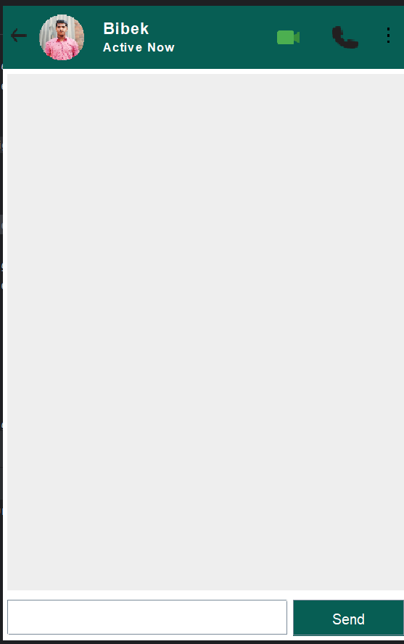

SERVER:

A server is a computer program that provides services to other computer programs (and their users) in the same or other computers. The computer that a server program runs in is also frequently referred to as a server. That machine may be a dedicated server or used for other purposes as well. Example Server, Database, Dedicated, File server, Proxy Server, Web Server. The server is always waiting for client’s requests. The client come and go down but the server remains the same.

A server application normally listens to a specific port waiting for connection requests from a client. When a connection request arrives, the client and the server establish a dedicated connection over which they can communicate. During the connection process, the client is assigned a local port number, and binds a socket to it. The client talks to the server by writing to the socket and gets information from the server by reading from it. Similarly, the server gets a new local port number (it needs a new port number so that it can continue to listen for connection requests on the original port). The server also binds a socket to its local port and communicates with the client by reading from and writing to it. The client and the server must agree on a protocol that is, they must agree on the language of the information transferred back and forth through the socket. Normally, a server runs on a specific computer and has a socket that is bound to a specific port number. The server just waits, listening to the socket for a client to make a connection request.
2.THE SERVER SCREEN

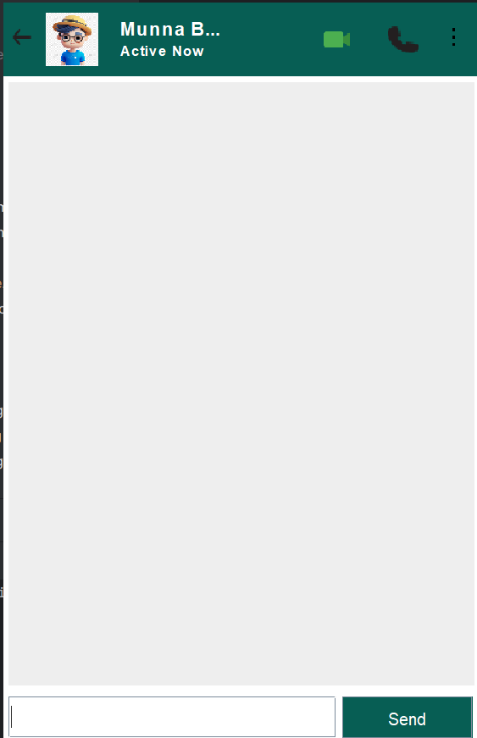

3. DATABASE SCREEN

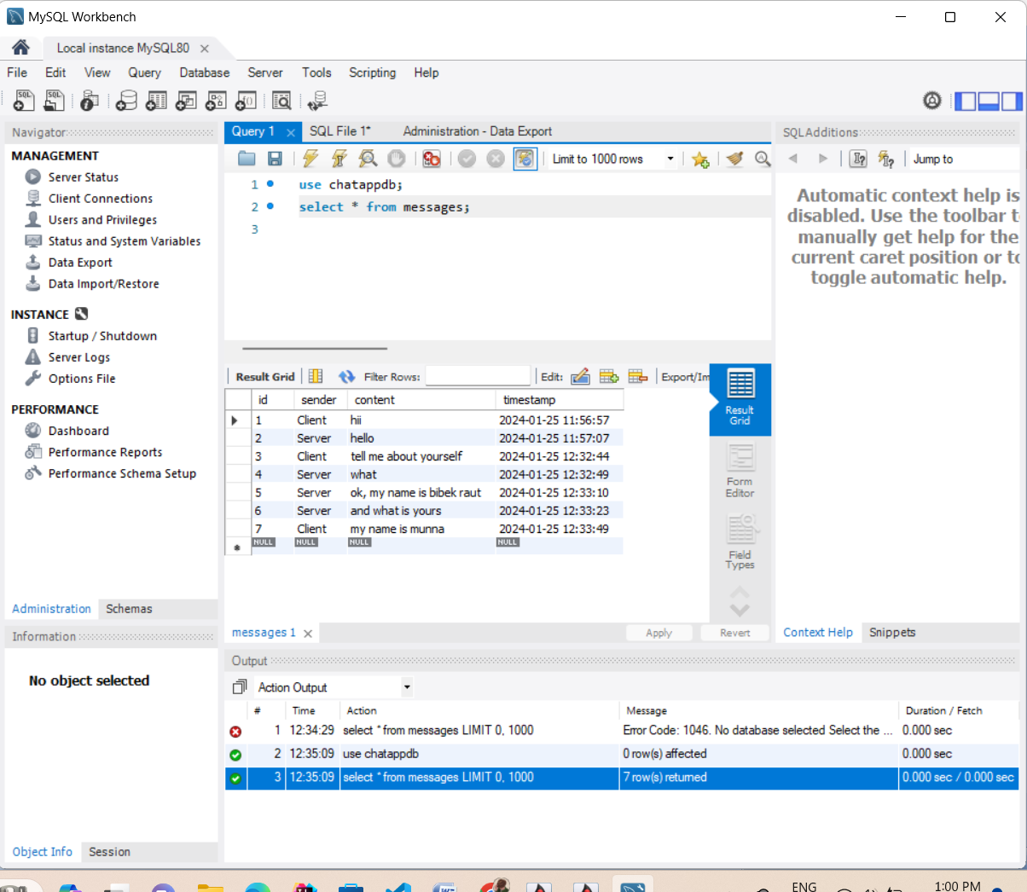
Future work

There is always a room for improvements in any software package, however good and efficient it may be done. But the most important thing should be flexible to accept further modification. Right now we are just dealing with text communication. In future this software may be extended to include features such as:
Files transfer: this will enable the user to send files of different formats to others via the chat application.

Voice chat: this will enhance the application to a higher level where communication will be possible via voice calling as in telephone.

Video chat: this will further enhance the feature of calling into video communication.

Also, the code can be further maintained and updated to be used as group chatting application also.
Conclusion

I developed network applications in Java by using sockets, threads, and Web services. These software is portable, efficient, and easily maintainable for large number of clients. Our developed web-based chatting software is unique in its features and more importantly easily customizable. The java.net package provides a powerful and flexible set of classes for implementing network applications. Typically, programs running on client machines make requests to programs on a server Machine. These involve networking services provided by the transport layer. The most widely used transport protocols on the Internet are TCP (Transmission control Protocol) and UDP (User Datagram Protocol).

TCP is a connection-oriented protocol providing a reliable flow of data between two computers. On the other hand, UDP is a simpler message-based connectionless protocol which sends packets of data known as datagrams from one computer to another with no guarantees of arrival.

